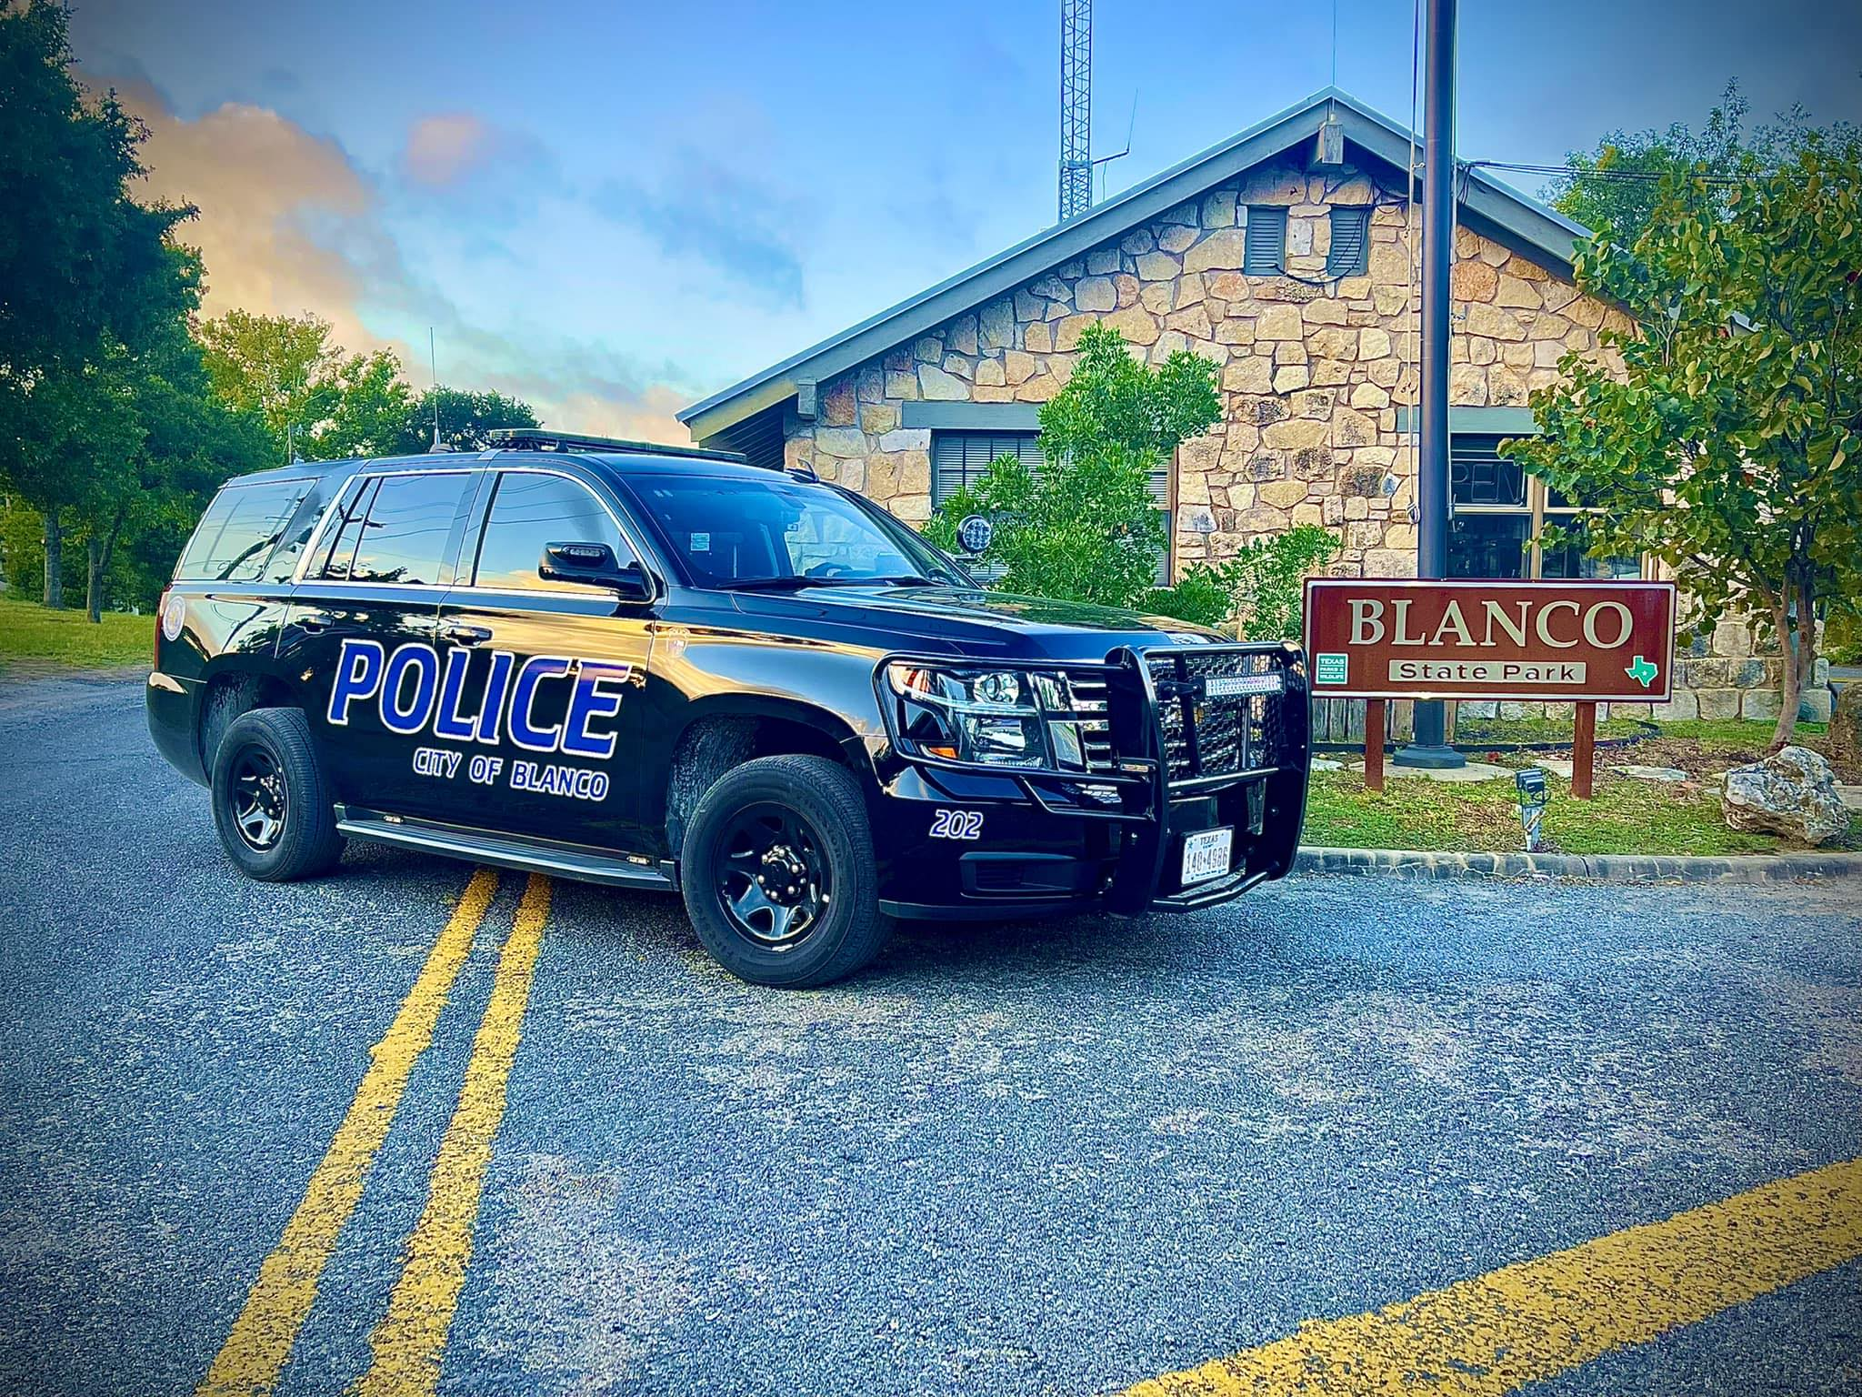

**City of Blanco Police Department**

**Chief’s Monthly Report**

December 2024

Jerry Thornhill,

Chief of Police

Chief’s Monthly Report—December 2024

**Department News**

The Police Department observed a continued upward trend in crime from November to December. While there was only a modest increase in calls for service within the city limits, rising by 13 calls, there was a significant surge in requests to assist other law enforcement agencies, which increased by 46 calls during December.

This notable rise in interagency assistance highlights the ongoing challenges faced by the law enforcement profession, particularly the nationwide staffing shortages. The current downturn in individuals pursuing careers in law enforcement has exacerbated the strain on agencies, both locally and across the country. These staffing shortages not only impact the capacity of agencies to manage their own jurisdictions effectively but also increase the reliance on mutual aid and interagency support to meet operational demands.

This trend underscores the need for proactive efforts to address recruitment and retention challenges within the field of law enforcement. Without strategic solutions, the ability of agencies to maintain public safety and effectively respond to calls for service could be further compromised.

**Community Events & Involvement**

Chrisman Day Parade – This year's parade saw a significant increase in both the number of floats and the overall attendance compared to previous years, reflecting the growing popularity of the event. Despite the larger turnout, the parade was highly successful. There were only a few minor challenges, primarily related to traffic congestion and temporary delays along US Highway 281. These issues were efficiently managed to minimize their impact on both event attendees and regular traffic. Moving forward, we can explore strategies to further streamline traffic control and enhance the overall experience for participants and the community.

**Staffing**

As we continue our efforts to address staffing needs and fill the remaining vacancies within the department, it is with sincere regret that I inform the City Council of an upcoming departure. Lieutenant Victoria McMain, a cornerstone of the Blanco Police Department and one of our most dedicated and accomplished officers, has been offered an exceptional opportunity to further her career. She has been recruited by the Texas Attorney General’s Office to serve as a Sergeant Investigator with the Victims Crimes Unit. While her departure is undoubtedly a significant loss for our department, it reflects her extraordinary talent and commitment to public service. We are immensely proud of her accomplishments and are confident that she will continue to excel in her new role. We extend our heartfelt congratulations and best wishes to Lieutenant McMain as she embarks on this next chapter in her career.

In other positive developments, I am pleased to report that Milton Saltmarsh has successfully passed the TCOLE licensing examination, a critical milestone in his journey to becoming a certified peace officer. Following this achievement, he has been approved to enter the Field Training Program, scheduled to begin later this month. His participation in this program is contingent upon the successful completion of his final psychological examination, as mandated by Texas state law. We remain optimistic about his progress and look forward to integrating him further into our team as he advances through the training process.

**Department Statistics**

Patrol Operations

|  |  |  |
| --- | --- | --- |
| **Total Calls for Service** | **September 2024** | **+/- Previous Month** |
| -In city | 201 | +13 |
| -Out of city | 60 | +46 |
| **Agency Assist** | 11 | -7 |
| **Traffic Stops** |  |  |
| -Total Vehicles Stopped | 43 | -28 |
| -Resulting Citations | 2 | -26 |
| -Resulting Warnings | 41 | -15 |
| **Arrests** |  |  |
| -On view | 3 | -0 |
| -Warrants | 0 | -3 |
| **Motor Vehicle Collisions** | 8 | -5 |

*Detailed statistics to follow further into the report.*

*It is important to note these statistics represent reported Calls for Service and not verified offenses or incidents*

**Administrative Operations**

* **Chief Activities**

For the month of December, Chief Thornhill dedicated numerous hours to community engagement and service through the Blue Santa Toy Drive. Thanks to the exceptional support from citizens and community members, the department surpassed expectations. As a result, several hundred toys were successfully provided to the Hill Country Advocacy Center for distribution throughout Blanco County.

* **Records Requests**

The Police Department received and fulfilled a total of 7 records requests in November 2024.

* **Fleet Updates**

|  |  |  |
| --- | --- | --- |
| Fleet IN COMMISSION | 6 |  |
| Fleet IN REPAIR | 0 |  |
| Fleet OUT OF COMMISSION | 3 | Units 171, 181, 182 |

**Criminal Investigations Division**

|  |  |  |
| --- | --- | --- |
| **Number of Reports Taken** | **Total** | **+/- previous month** |
| -resulting in offense report | **31** | **+16** |
| -resulting in informational/other report | **14** | **-1** |
| **Offenses Filed** |  |  |
| -felony | **0** | **-2** |
| -misdemeanor | **3** | **-1** |

In December, Lieutenant McMain and Chief Thornhill diligently collaborated on the resolution of numerous criminal cases. Their efforts led to the successful conclusion of 54 cases, each of which was thoroughly investigated, finalized, and assigned a permanent disposition. This accomplishment reflects their commitment to ensuring justice and maintaining the integrity of the investigative process.

**Regional Involvement**

* Child Fatality Review Team
* Hill Country Crimes Against Children Multi-Disciplinary Team
* Behavioral Health Leadership Team
* Community Paramedic Expansion Project
* Community Mental Health Awareness Team
* Sexual Assault Response Team

Lieutenant McMain regularly engages in regional multi-disciplinary team meetings (as listed above) to ensure the highest quality and continuity of services to the citizens of our community; specifically, children, victims of crimes against persons, and mental health consumers. This month due to staffing levels, Lieutenant McMain was unable to attend any of the regional meetings except for the meetings requiring regular attendance through state mandate.

**Detailed Statistics**

**Total Traffic Stops: 43**

|  |  |  |
| --- | --- | --- |
| **Traffic Violations by Type** | **Resulting in Citation** | **Resulting in Warning** |
| Moving Violation | 2 | 41 |
| Non-Traffic Violation | 0 | 1 |
| School Zone Violation | 0 | 9 |

*\*Some traffic stops resulted in multiple citations/warnings if the officer addressed more than one violation*

**Arrests Made by Month**

|  |  |  |  |  |  |  |  |  |  |  |  |  |
| --- | --- | --- | --- | --- | --- | --- | --- | --- | --- | --- | --- | --- |
| **Month** | **Jan** | **Feb** | **Mar** | **Apr** | **May** | **Jun** | **Jul** | **Aug** | **Sept** | **Oct** | **Nov** | **Dec** |
| **Adult** | 10 | 5 | 5 | 0 | 3 | 1 | 2 | 3 | 1 | 4 | 6 | 3 |
| **Juvenile** | 0 | 0 | 0 | 0 | 0 | 0 | 0 | 0 | 0 | 0 | 0 | 0 |
| **Total** | 10 | 5 | 5 | 0 | 3 | 1 | 2 | 3 | 1 | 4 | 6 | 3 |

**Calls for Service by Month**

|  |  |  |  |  |  |  |  |  |  |  |  |  |
| --- | --- | --- | --- | --- | --- | --- | --- | --- | --- | --- | --- | --- |
| **Month** | **Jan** | **Feb** | **Mar** | **Apr** | **May** | **Jun** | **Jul** | **Aug** | **Sept** | **Oct** | **Nov** | **Dec** |
| **Total** | 252 | 218 | 176 | 173 | 180 | 112 | 95 | 156 | 207 | 220 | 203 | 261 |

**Offenses by Month**

|  |  |  |  |  |  |  |  |  |  |  |  |  |
| --- | --- | --- | --- | --- | --- | --- | --- | --- | --- | --- | --- | --- |
| **Month** | **Jan** | **Feb** | **Mar** | **Apr** | **May** | **Jun** | **Jul** | **Aug** | **Sept** | **Oct** | **Nov** | **Dec** |
| **Total** |  |  |  |  |  |  |  | 11 | 6 | 19 | 12 | 8 |

\**Offense data not collected prior to August 2024*

**Motor Vehicle Collisions by Month**

|  |  |  |  |  |  |  |  |  |  |  |  |  |
| --- | --- | --- | --- | --- | --- | --- | --- | --- | --- | --- | --- | --- |
| **Month** | **Jan** | **Feb** | **Mar** | **Apr** | **May** | **Jun** | **Jul** | **Aug** | **Sept** | **Oct** | **Nov** | **Dec** |
| **Total** | 6 | 6 | 10 | 8 | 8 | 16 | 10 | 8 | 12 | 10 | 13 | 8 |

**Miles Patrolled by Month**

|  |  |  |  |  |  |  |  |  |  |  |  |  |
| --- | --- | --- | --- | --- | --- | --- | --- | --- | --- | --- | --- | --- |
| **Month** | **Jan** | **Feb** | **Mar** | **Apr** | **May** | **Jun** | **Jul** | **Aug** | **Sept** | **Oct** | **Nov** | **Dec** |
| **Total** |  |  |  |  |  |  |  |  | 2141 | 2399 | 2665 | 1800 |

*\*Data not available prior to September 2024*

**Monthly Report of Incident by Incident Type**

|  |  |
| --- | --- |
| **Call Type** | **Number of Calls** |
| 911 Open Line | 2 |
| Administrative | 1 |
| Alarm - Business | 7 |
| Animal Bite | 1 |
| Animal Complaint | 2 |
| Assist Public | 5 |
| Burglary | 1 |
| Business Check | 10 |
| Cardiac Arrest | 1 |
| Cardiac Problems | 1 |
| Chest Pain | 1 |
| Civil | 4 |
| CP | 72 |
| Criminal Mischief | 2 |
| Diabetic | 1 |
| Disturbance - Physical | 1 |
| Disturbance - Verbal | 7 |
| Domestic Non-Violent | 1 |
| Domestic Violent | 3 |
| Drugs | 1 |
| Emotion Dist Person | 2 |
| Fall - Injury | 1 |
| Fight | 1 |
| Found Property | 2 |
| Fraud | 1 |
| Illegal Burn | 1 |
| Informational | 5 |
| Inmate Transport | 1 |
| Intoxicated | 1 |
| Investigations | 2 |
| Loose Livestock | 3 |
| Medical - Unknown | 2 |
| Missing Person | 1 |
| Motorist Assist | 1 |
| MVA - Injury | 7 |
| MVA - Non Injury | 7 |
| MVA - Unknown Injury | 1 |
| Noise Complaint | 2 |
| Reckless Driver | 16 |
| Shots Fired | 1 |
| Sick Person | 1 |
| Special Assignment | 1 |
| Stolen Property | 1 |
| Suicidal Person | 1 |
| Suspicious Circumstance | 2 |
| Suspicious Person | 4 |
| Suspicious Vehicle | 3 |
| Terroristic Threat | 1 |
| Theft | 2 |
| Threats | 2 |
| Traffic Hazard | 6 |
| Traffic Stop | 42 |
| Training Incident | 1 |
| Traumatic Injury | 1 |
| Trespass | 2 |
| Unconscious | 1 |
| Welfare Check | 5 |
| Uncategorized | 3 |
| **TOTAL** (including uncategorized calls for service) | 261 |

\**Note, numbers reflect the incident type the call was dispatched as, not necessarily what the incident type and/or offense was determined to be*. *Additionally, some incidents required multiple incident codes and can be listed under many categories.*

**Summary**

In December 2024, the Blanco Police Department experienced a modest increase in in-city service calls (+13) and a significant rise in interagency assist requests (+46), highlighting ongoing staffing challenges and the growing reliance on mutual aid. The department successfully managed a highly attended Chrisman Day Parade despite minor traffic issues and continued its community engagement efforts through the Blue Santa Toy Drive, which provided hundreds of toys to local families. Staffing updates included the resignation of Lieutenant Victoria McMain, who accepted a position with the Texas Attorney General’s Office, and the onboarding of Milton Saltmarsh, who advanced to the Field Training Program. Operationally, the department handled 261 calls for service, conducted 43 traffic stops (resulting in 2 citations and 41 warnings), made 3 arrests, and resolved 54 criminal cases. While regional involvement was limited due to staffing, the department maintained its commitment to public safety and community service. Fleet operations remained stable, with six vehicles in commission and three out of service. Despite challenges, the department demonstrated adaptability and effectiveness in meeting community needs.

**Disclosure**

Many data collection sources were utilized to compile the presented informatio0n to include Record Management System reporting and administrative logs. In our continued effort to report accurate and transparent numbers, the department discloses that the RMS system is continuously updated and reports run at various times, sometimes producing different results. Care should be taken when comparing this monthly report to other data reports as different data collection methods and data sources may be used. The data provided is for informational use only.